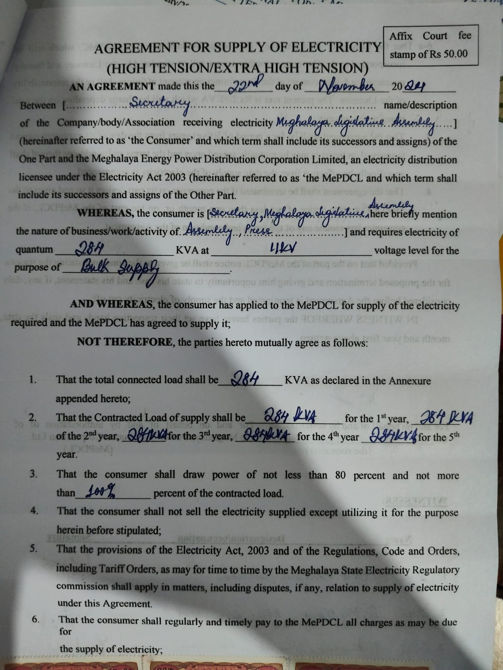

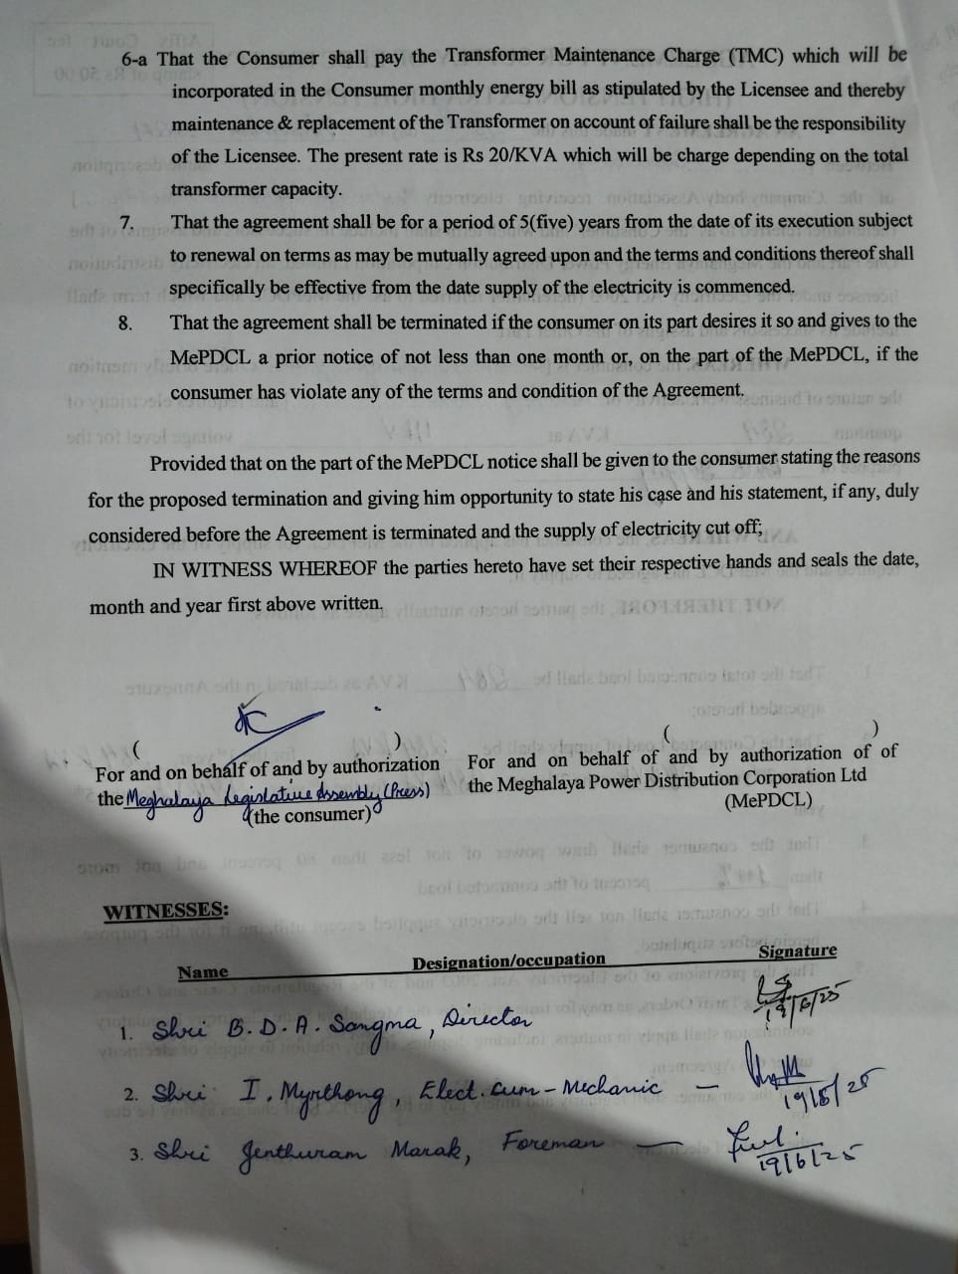

Note: The Consumer is an existing consumer, the date of installation of the enhanced capacity is on November, 2024 but the load drawal against the new Contract demand is recent.