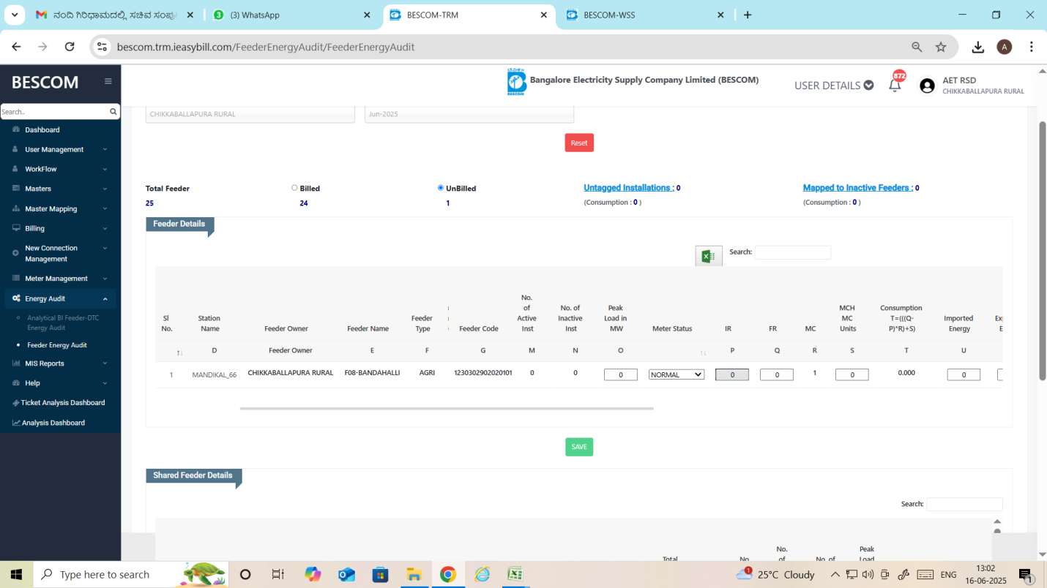

SIR,

PLEASE CHANGE METER CHANGE CONSTANT.

F08-BANDAHALLI AGRI FEEDER METER CONSTANT HAS CHANGE TO 1 TO 1000.