ITL/MEGH/2025-26/26 Dated, Guwahati, the 13th August 2025
To,
…………………..
……………………………… .

Sub: DN Payment for the site KGLH02 for EB service connection.
Dear Sir/Madam,

We would like to inform that the payment against the site KGLH02 has been done by Indus Towers Limited (Bharti Infratel Limited) in favour of MePDCL DEPOSIT WORKS ACCOUNT

The payment details are mentioned as under.

Indus site id | Payment Mode | Address | Amount | Invoice Description | UTR/ DD DOC NO | DD/NEFT DATE
IN-3334763 | NEFT | Dorbar Shnong Laitmawsiong,R/o Laitmawsiong, Po/Ps Sohra,Dist East khasi hills,793108, Meghalaya. Headmen name-Jiwon Riahtam,Contact 9863116735. | 1,77,236 | DN Payment at  KGLH02 | HDFCN52025081210015422 | 12/08/2025

You are kindly requested to consider and acknowledge the same.
Thanking you.
Yours faithfully
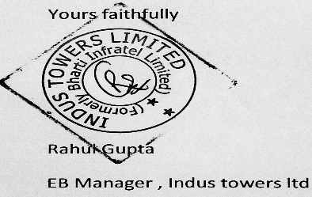
EB ,MANAGER ,ITL

