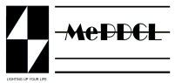**MEGHLAYA POWER DISTRIBUTION CORPORATION LIMITED**

**OFFICE OF THE ASSISTANT EXECUTIVE ENGINEER**

**UMSNING DISTRIBUTION SUB-DIVISION, UMSNING**

No. MePDCL/AEE/USDSD/T-11/2025-26/ Dated, Umsning, the 23rd May 2025

This is to certify that the attached list of new service connection consumers is correct and has been compiled from their verified documents submitted by the respective applicants.

(K. Manih)

Assistant Executive Engineer

Umsning Distribution Sub Division

MePDCL,Umsning