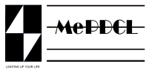
MEGHLAYA POWER DISTRIBUTION CORPORATION LIMITED
OFFICE OF THE ASSISTANT EXECUTIVE ENGINEER
UMSNING DISTRIBUTION SUB-DIVISION, UMSNING

No. MePDCL/AEE/USDSD/T-11/2025-26/ Dated, Umsning, the 23rd May 2025

This is to certify that the attached list of new service connection consumers is correct and has been compiled from their verified documents submitted by the respective applicants.

(K. Manih)
Assistant Executive Engineer
Umsning Distribution Sub Division
MePDCL,Umsning

